Steps for Using External (formerly “male”) Condoms

- Check expiration date on condom package.

- Push (squeeze) the condom to one side and open the package, being careful not to tear the condom.
- Check to be sure that the condom will roll down the penis correctly. 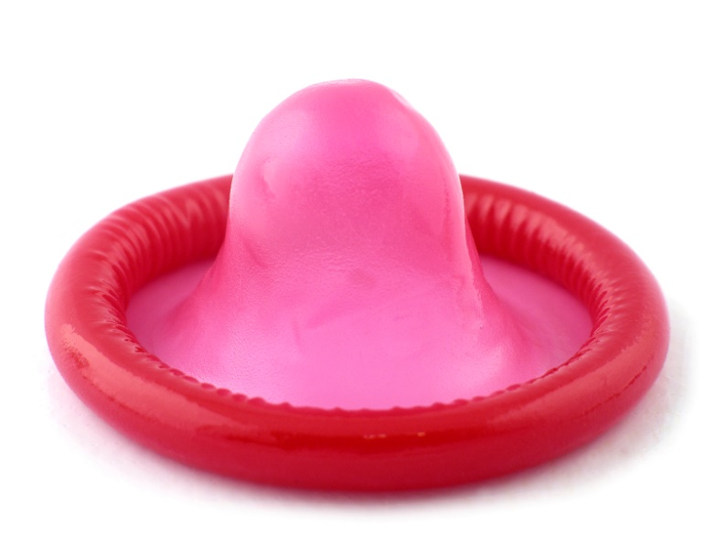
Condoms roll in only one direction.

- Pinch air out of the tip of the condom.

- Put the condom on the tip of the erect penis before any contact between the penis and a partner’s genitals, mouth or anus. If the penis is not circumcised, pull back the foreskin before putting on the condom.
- Unroll the condom to the base of the penis. Smooth out any extra air. Put lubricant on the outside of the condom if you wish.

- Check during intercourse to make sure the condom is
not slipping.
- After sex, hold the condom firmly by the rim at the base and withdraw (pull out) while the penis is still erect.

- Remove the condom by rolling it off. Do this away from your partner’s body.

- Wrap the condom in tissue and throw it away. Do not flush condoms down the toilet.
- Never reuse a condom. If you want to have sex again, always use a new condom.

